Public Lecture
Mainstreaming Distance Education
Opportunities and Challenges

In this session I will take a critical look at the key attributes of open, flexible and distance learning and review its opportunities and challenges for contemporary society and systems, and issues to do with accreditation and credit transfer including:
- Notions of the “separation” of the teacher and the learner from the perspectives of time and space;
- Influence and role of an educational organization including different types of organizational models for transfer of credit;
- The full range of technologies that are used to connect and re-engage the teacher and the learner in distance education;
- The full range of technologies and opportunities employed in distance education to support all forms communication for learning, teaching and assessment among learners and learners and teachers in distance education;
- The role of face-to-face contact in distance education including the notions of blended and flexible learning, including how much, when and where in order to retain the integrity of DE as a viable alternative form of educational provision; and
- The progressive nature of distance education which is characterised by the disaggregation of roles and functions in it, unlike the aggregated form that is typical of conventional forms of education.

Presenter
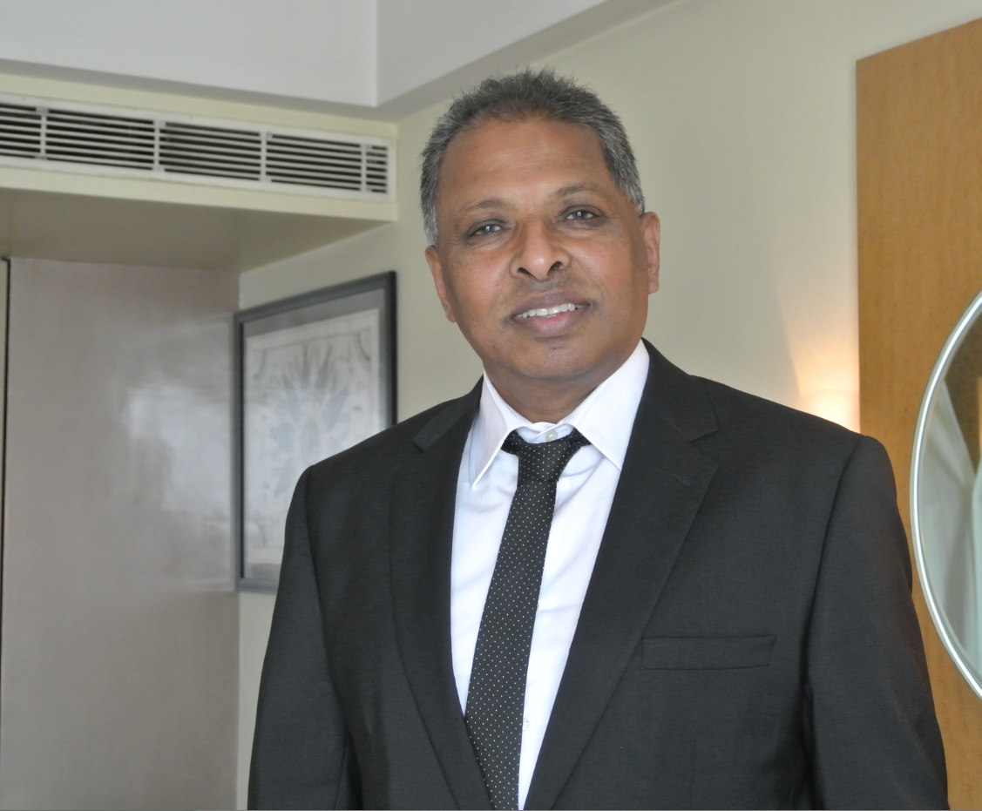
Som Naidu, PhD; D. Litt. (Honoris Causa)
Monash University, Melbourne, Australia
Email: somaiya.naidu@monash.edu.au; sommnaidu@gmail.com.

Principal Associate: Technology, Education and Design Associates
President: Open and Distance Learning Association of Australia (http://www.odlaa.org/)
Executive Editor: Distance Education [http://www.tandf.co.uk/journals/CDIE].
Assistant Editor: Interactive Learning Environments [http://www.tandf.co.uk/journals/NILE]
Routledge Education Arena Panel: http://www.educationarena.com/expertPanel/panel2/
Email: sommnaidu@gmail.com; somaiya.naidu@monash.edu.au

Dr. Naidu is currently an Affiliate Associate Professor at Monash University. He has previously served as Associate Professor (Learning Transformations) at Swinburne University of Technology in Melbourne, Associate Professor and Director of Teaching and Learning Quality Enhancement and Evaluation of Learning and Teaching at Charles Sturt University, NSW Australia, and Associate Professor of Educational Technology and Multimedia Education at the University of Melbourne.

Dr. Naidu possesses undergraduate qualifications in Education from the University of Waikato in New Zealand and graduate qualifications in Distance Education and in Educational Technology from Concordia University in Montreal, Canada. He has undertaken sabbaticals at Northwestern University (USA), Manchester Metropolitan University, and the University of London in the UK. His publications in the areas of his expertise include several books, book chapters, and more than a hundred peer-reviewed journal articles and refereed conference papers.

Dr. Naidu is the current president of the Open and Distance Learning Association of Australia, executive editor of its journal Distance Education, and assistant editor of the journal Interactive Learning Environments. In May 2014 the Open University of Sri Lanka awarded Dr. Naidu a D.Litt. (Honoris Causa), in recognition of his extensive contribution to the field of open, flexible, distance and e-learning both regionally and internationally.

